INTRODUCTION

react-testing-lib

Philosophy

- collection of best testing react practices

- focus testing the way user using (specification)

- not internal implementation (code runiing test - unit tét)

Difference things

- Find element by "accessibility marker" instead of testID

Provide DOM for tests

Jest - test runner

=> find test (in dir)

=> run test (by script)

=> determine result => in log

CREAT-REACT-APP, include

- configuration

- webpack, babel

- webserver (run js code)

- testing Lib

Jest and Jest-DOM Assertions

=> decide the test failed or not

- start with expext + argument (subject)

- matcher

- DOM matcher: toBeInTheDocument(), toBeVisible()

- normal matcher: toBe('hello')

- jest-dom:

- comes with create=react=app

JEST

React Testinng Lib, provide

- render virual dom

- searching element in virtual dom

- interact with VD (clicking..)

Need Test-runner to run

- Make assertion, run test..

- test runner - Jest

- comwith react app

- suggested

- other like mocha, japmine

ABout watchmode

- watch changes in file (from last commit) => commit no test :3

- only run when changes

TDD: TEST DRIVEN DEVELOPMENT

Concept

* Write test => write code (to make test passed)
* Red-green testing philosophy
  + Red part: test failed B4 code
  + Green part: write code to pass tests

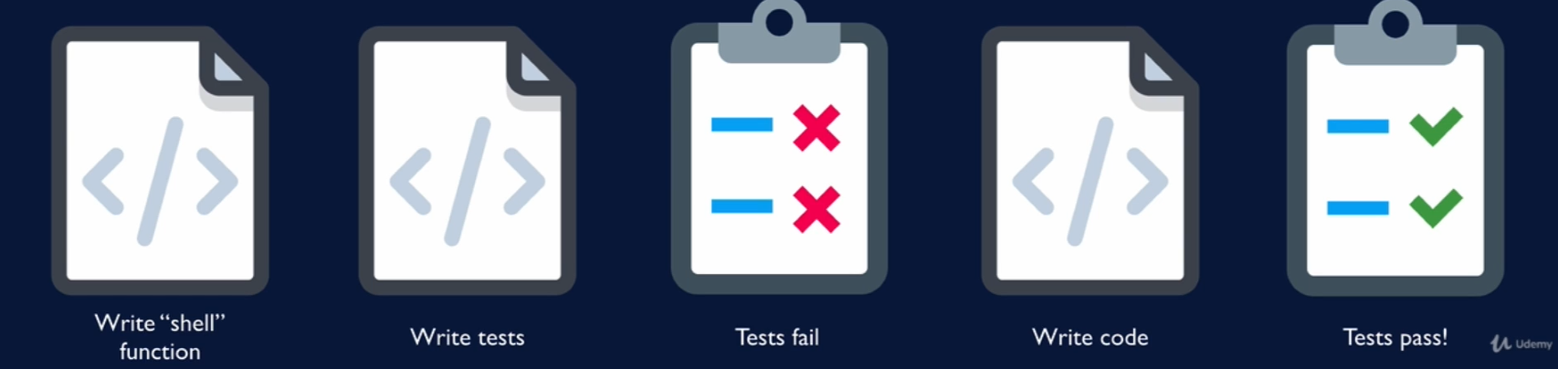

Why

* Elevate tests roles (it must be integrated instead of being a “chore” after the code finished)
* More efficient
  + Test always re-running with the app => test free => free quality check from very early

REACT TESTING LIB PHILOSOPHY

* Opiniated: best practices
* What does it do?

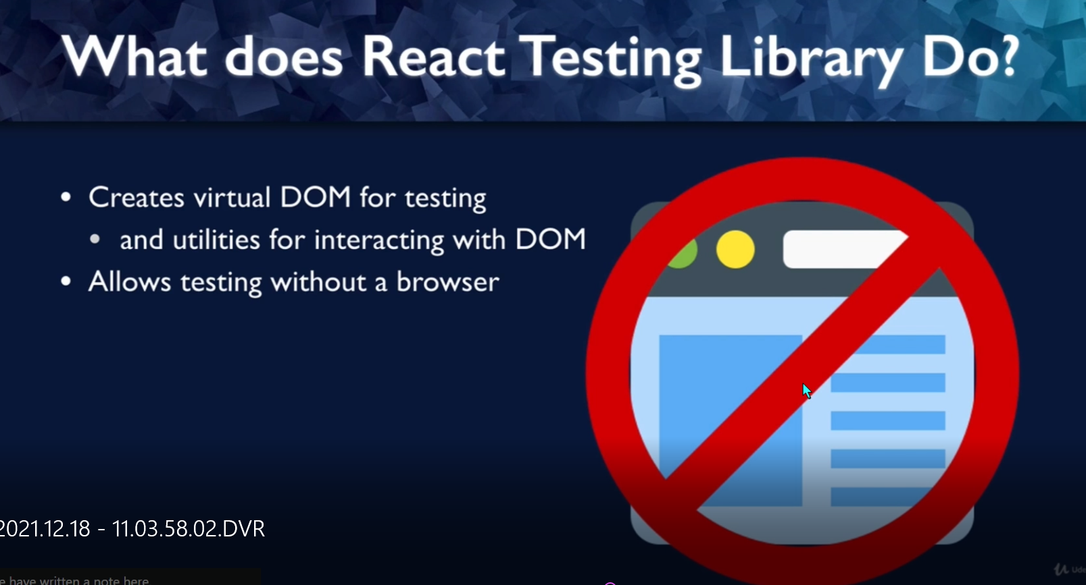

* Type of tests

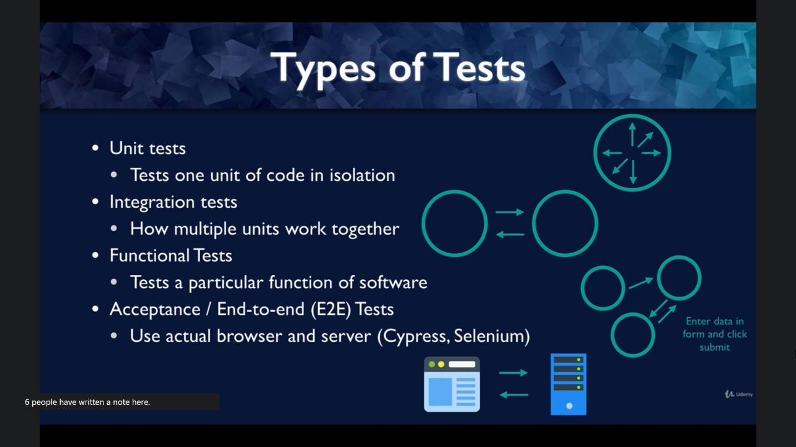

* Unit: function, components
* IT: multiple units: interaction between component, micro-services, etc
* Functional tests = behaviour test instead of testing your code (not UT, IT)
* Acceptance test or E2E test: reallife test
  + Required special tools (RTL not designed for)

FUNCTIONAL TESTING VS UNIT TESTING

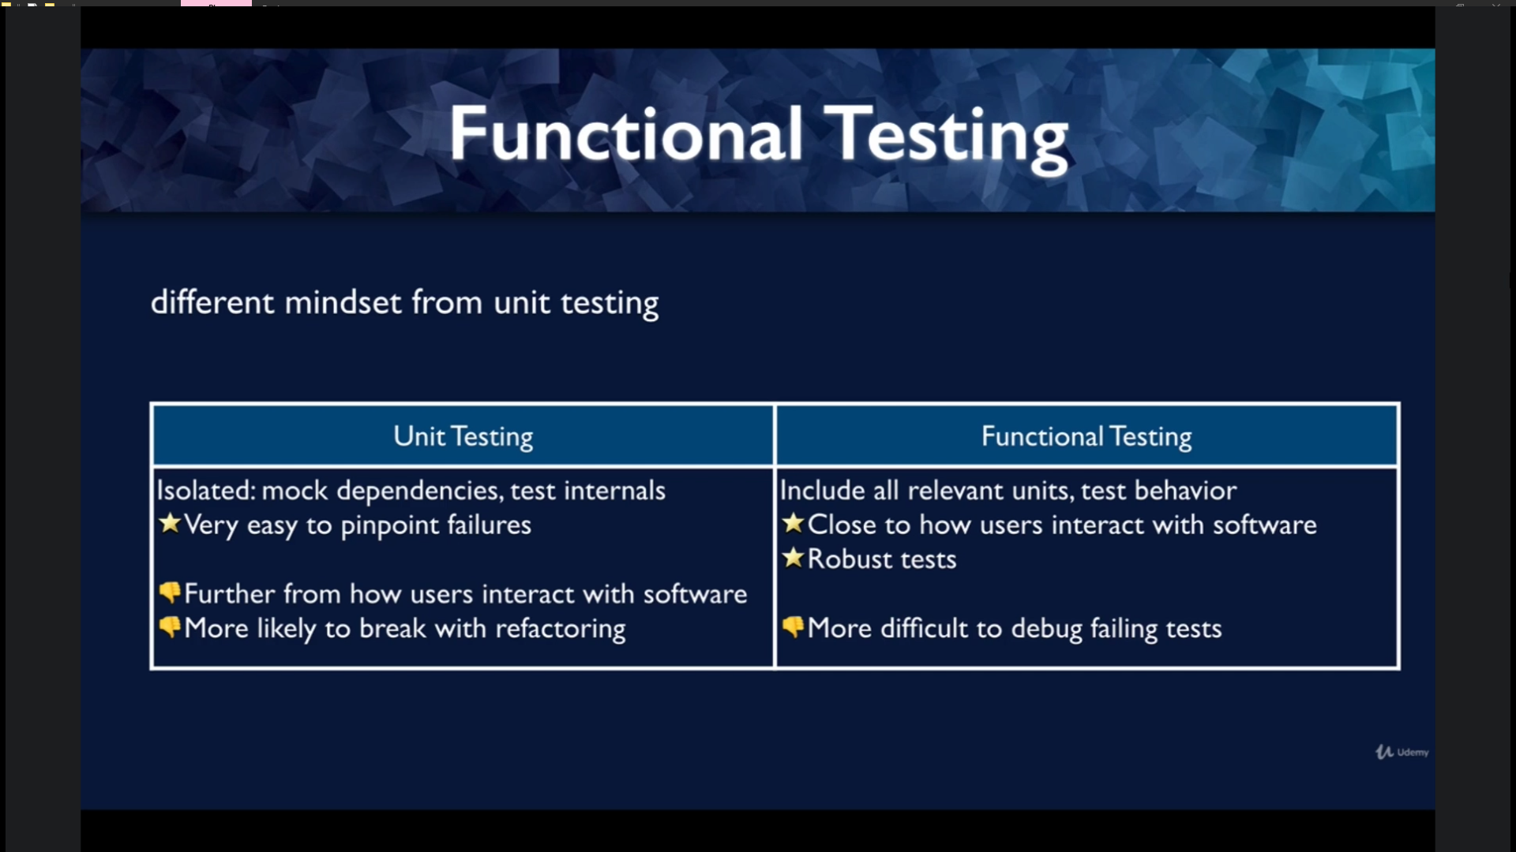

TDD vs BDD

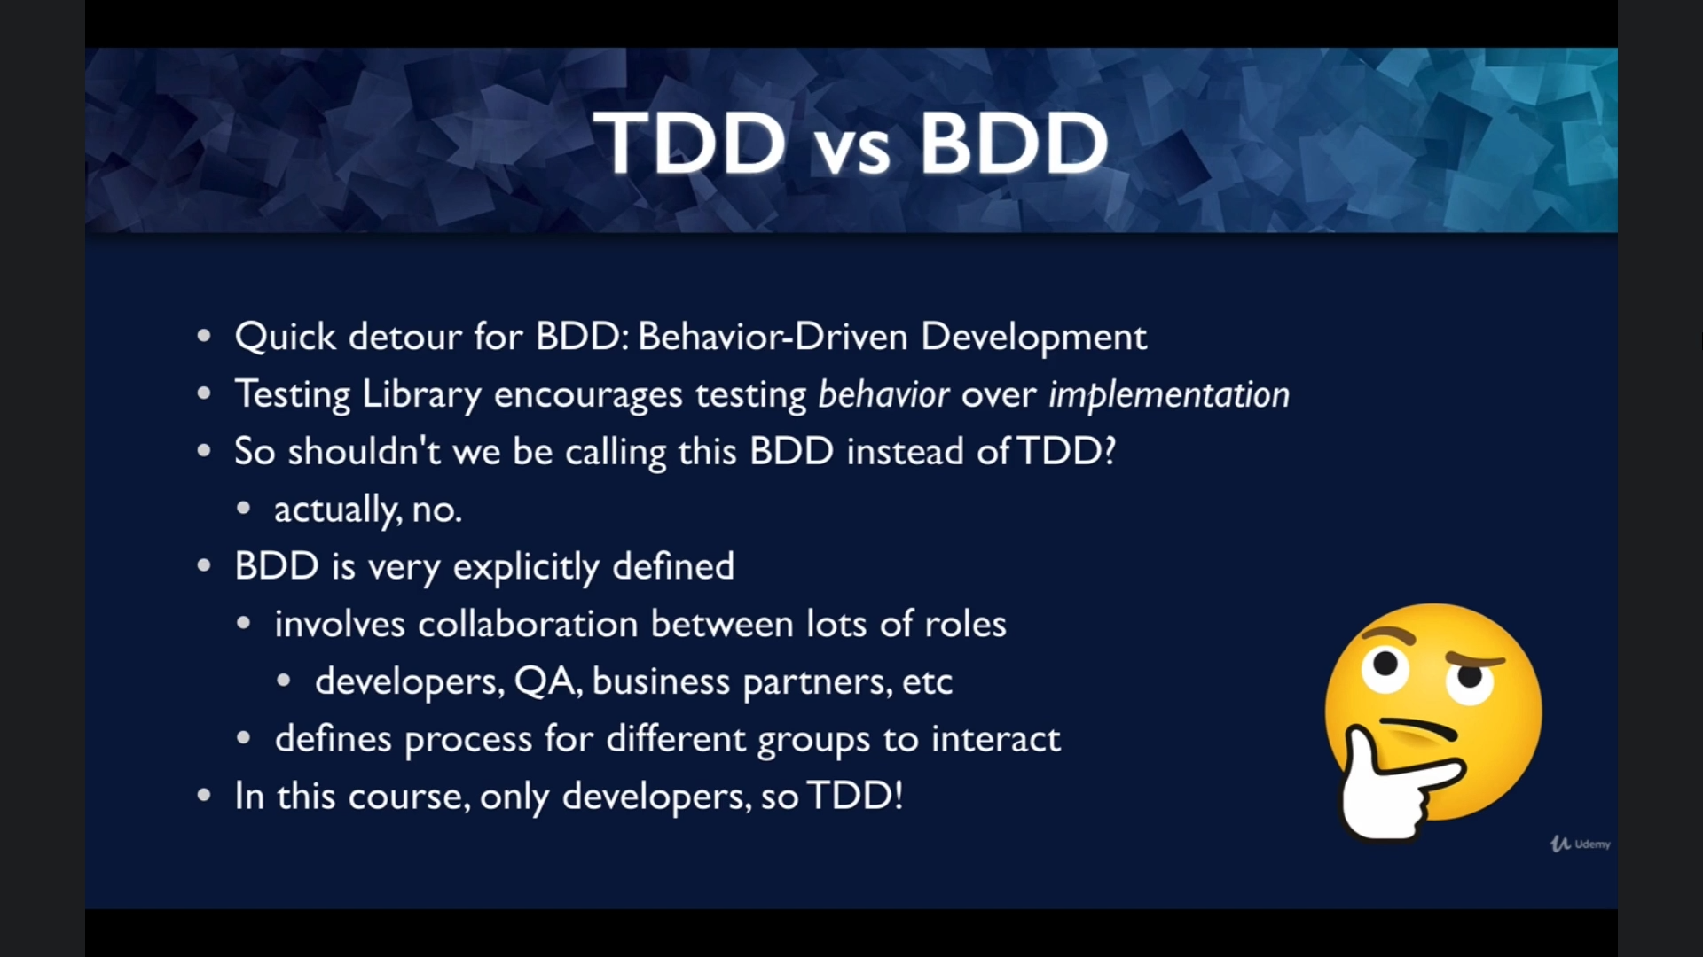

TESTING LIBRARY AND ACCESSIBILITY

FINDING ELEMENT BY ACCESSIBILITY HANDLES:

* Ref: <https://testing-library.com/docs/queries/about/#priority>
  + Accesibile Query: visbible to screen reader to do the user
    - getByRole (literally can be used to extract anything :3)
      * like so: getByRole('button', {name: /submit/i})
    - getByText
    - ...
  + Sematic Queries
  + Test Ids (last resources for not visibile to screen reader or user)
* Analyse one example: getByText
* The more exp you have with queries and roles the more you will familiar with these concepts and testing techstacks
  + Role ref: <https://www.w3.org/TR/wai-aria/#role_definitions>

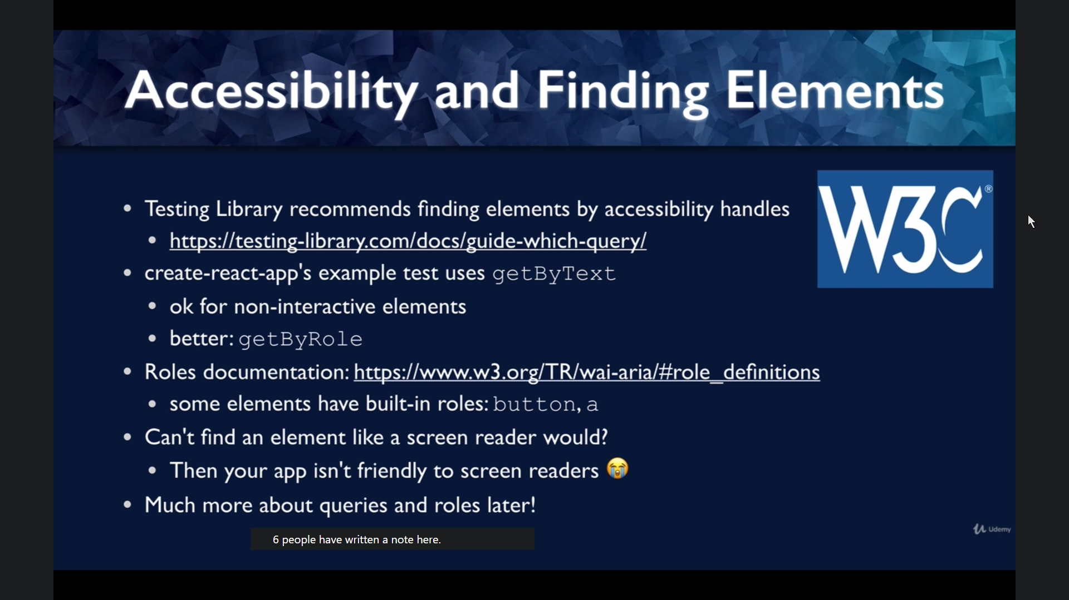

CHAPTER 2: PRACTICING NORMAL APP: COLOR BUTTON

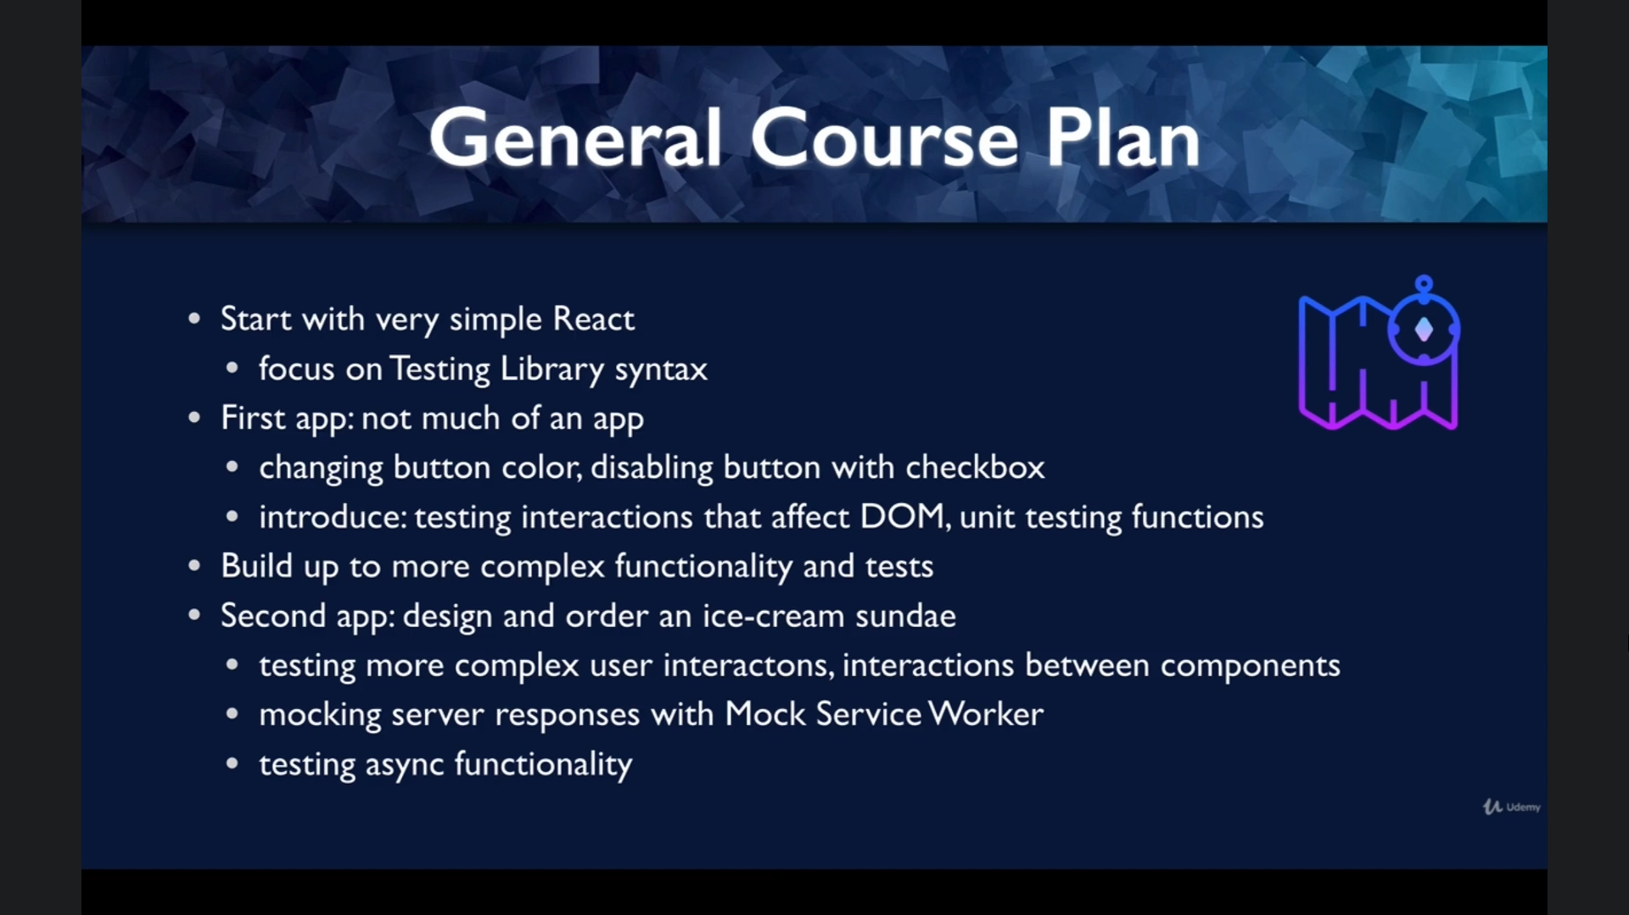

START WITH COLOR BUTTON APP

* Write the first red green test
  + Defined shell function
  + Write test: expect to have style – BG color red
  + Run failed => red part complete
  + Write code: with a button and red BG
  + Run succedded => green part complete
* How to find unknown roles
  + Ref: <https://github.com/testing-library/jest-dom>
  + Write unknown => get suggest by react testing lib
* Note:
  + You should write each unit test each test => 1 assertion each test
  + Fuctional test => multiple assertions
  + (option) fireEvent(component) to interact with DOM

MANUAL ACCEPTANCE TEST (L15)

* Just run the app and see what it likes – like a tester :3

UNIT TESTING FUNCTION

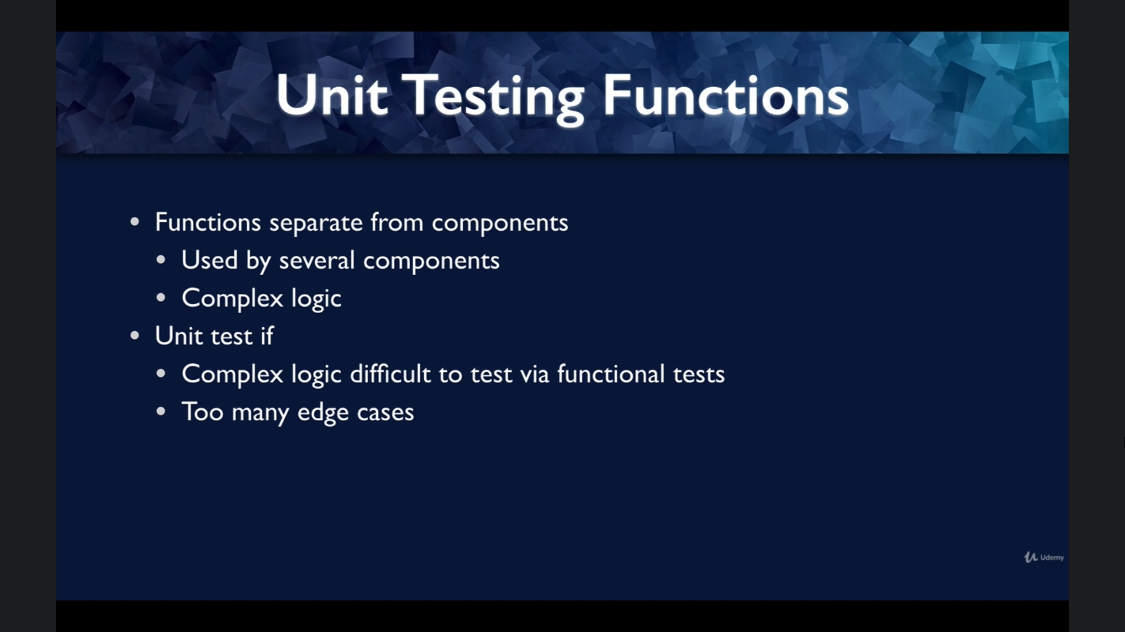

* Do this when it overskill to run functional test (or call render, firing events...) just for testing the funciontality of those utils funtions alone :3
* Help surrounding the bugs

WHEN TO UNIT TEST

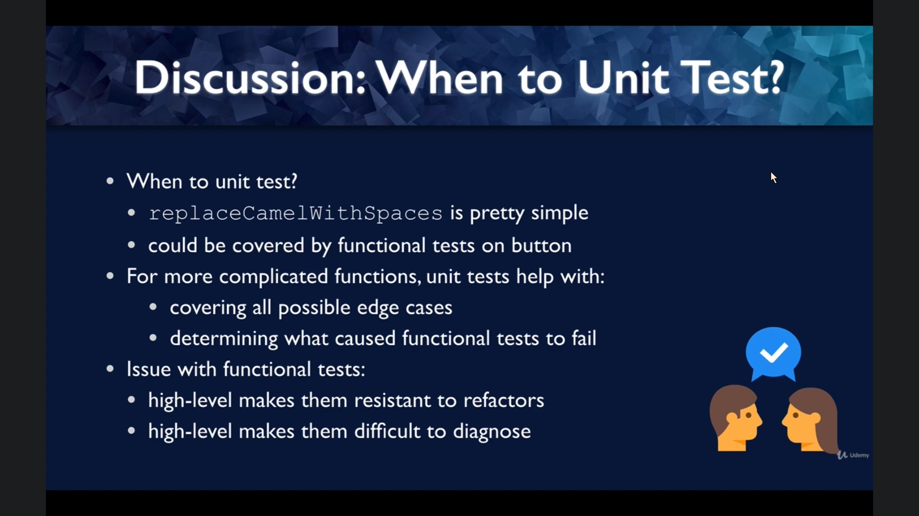

SUM UP: FIRST TESTING APP

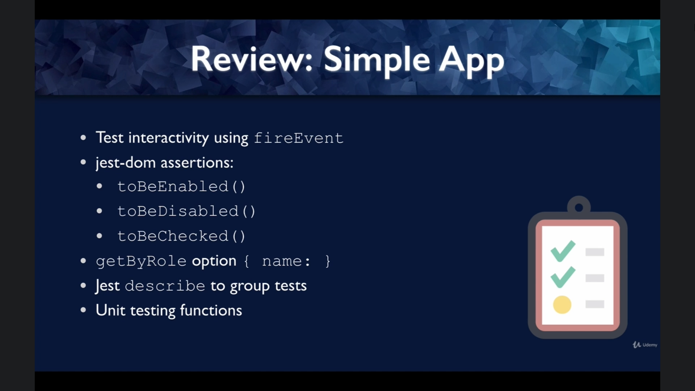

CHAP 3

ESLINT (LINTER) AND PRETTIER (CODE FORMATER)

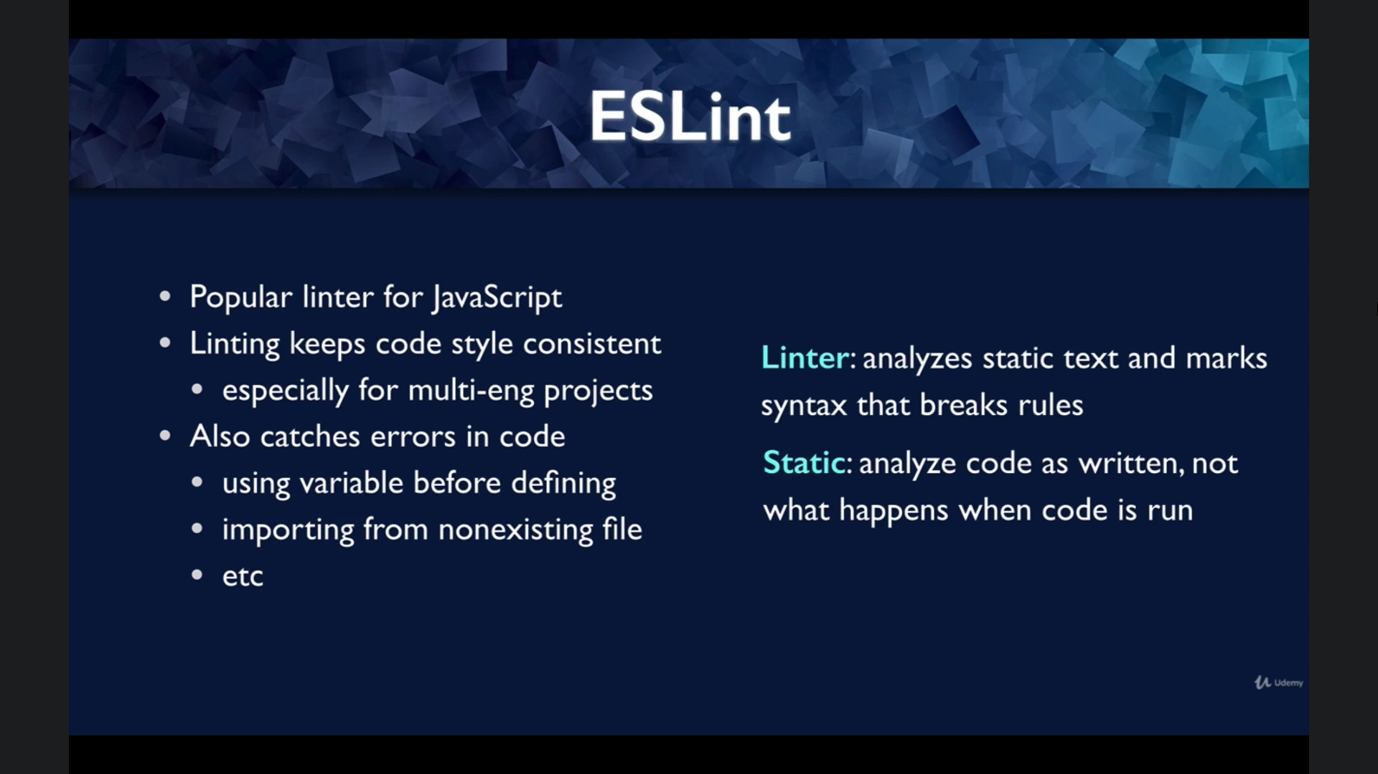

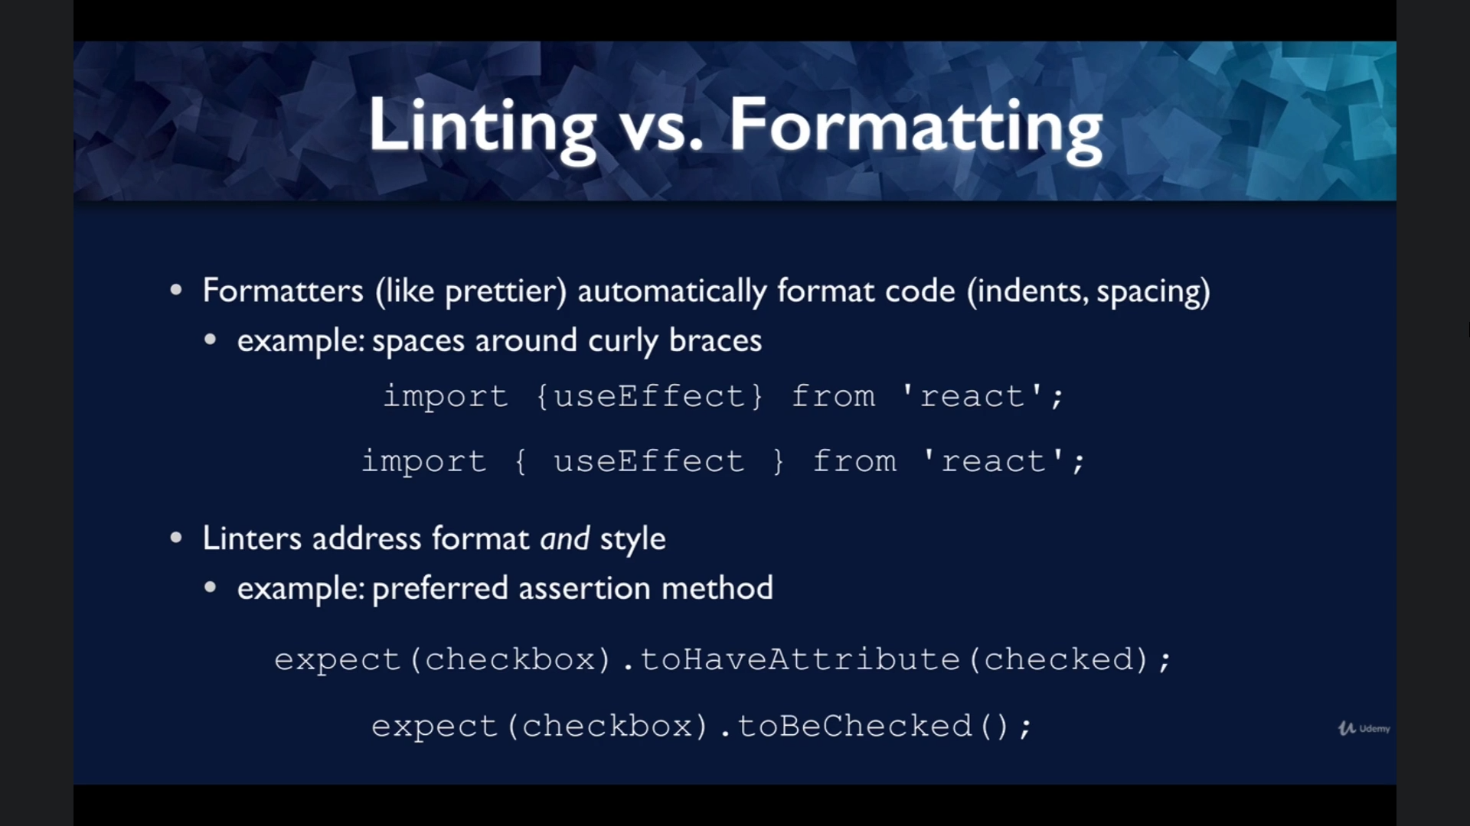

You can plug-in some linter tailored for react-testing-library

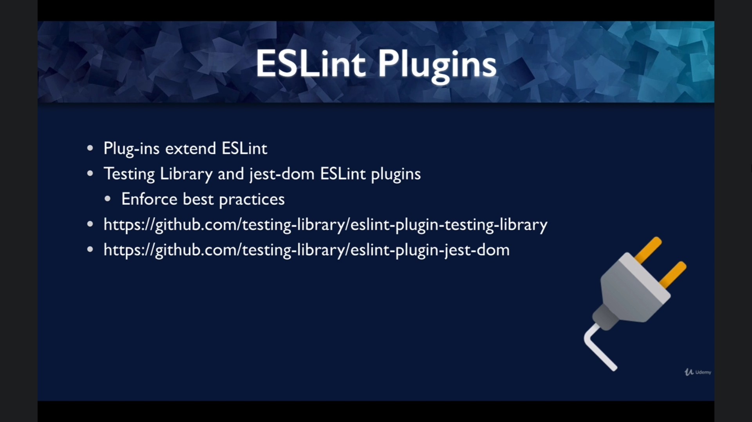

SETUP ESLINT FOR REACT TESTING LIB

1. npm install eslint-plugin-testing-library eslint-plugin-jest-dom
2. move default eslint config in package json => seperate file .eslintrc.json
3. "plugin:testing-library/recommended" – no longer support

Ref:

* <https://github.com/testing-library/eslint-plugin-testing-library>
* https://github.com/testing-library/eslint-plugin-jest-dom

CONFIG ESLINT IN VS CODE

* Create ./vscode
  + Specify where eslint.json
  + Specify type of files: [javascript, javascriptreact]
  + Auto fix when saving: “codeActionOnSave
    - Source.fixall.eslint: true
  + Install eslint extentions on VSCode
* Let screw it
  + Allow eslint if it disblaled: allow anywhere => double check mark
* Ignore
  + .vscode
  + .eslintcache
* Setting global
* Ref:
  + .vscode/settings.json: <https://code.visualstudio.com/docs/getstarted/settings#_settings-file-locations>

SUM UP THE CHAPTER

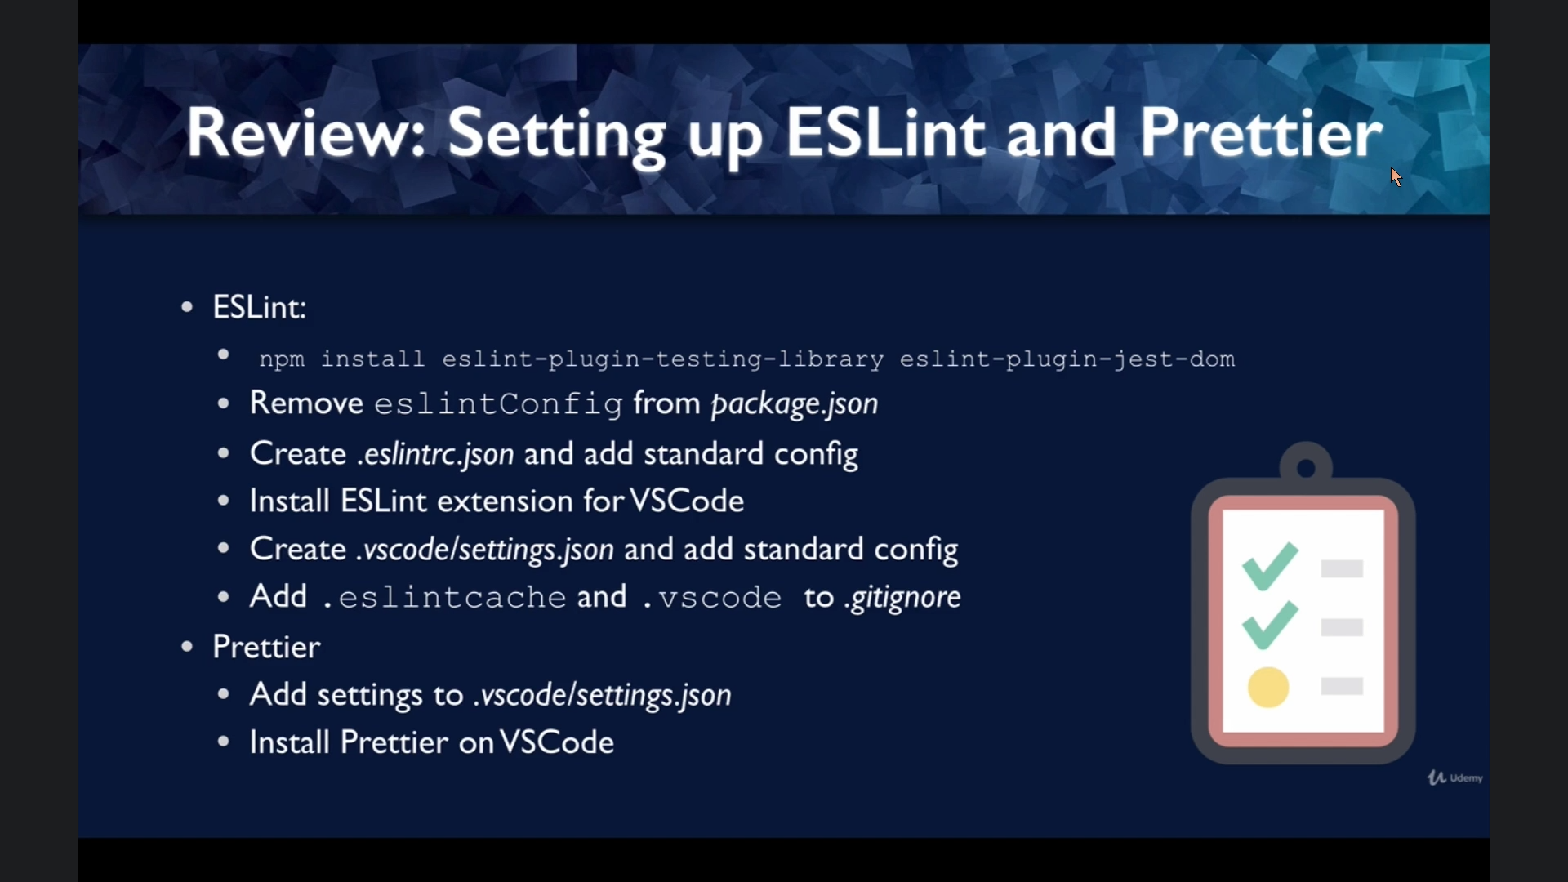

SUNDEAS-ON-DEMAND DESCRIPTIONS

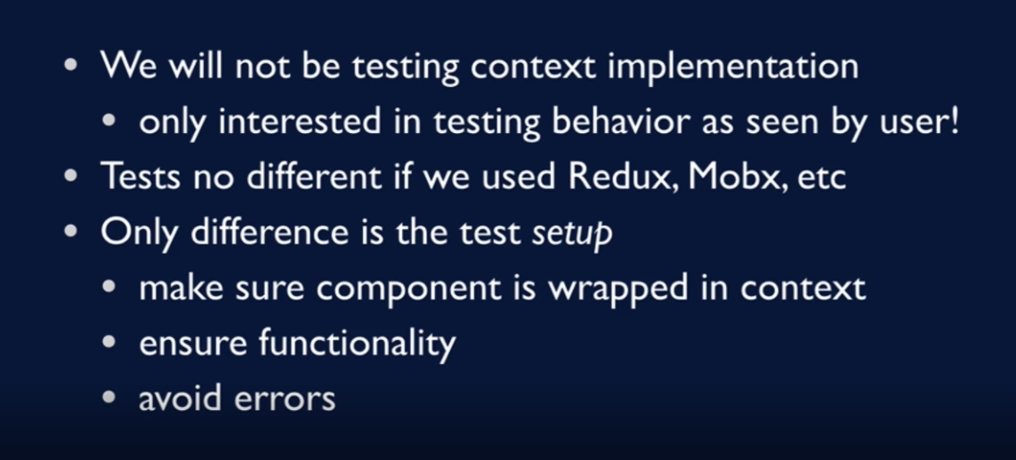

MOCK-UPS

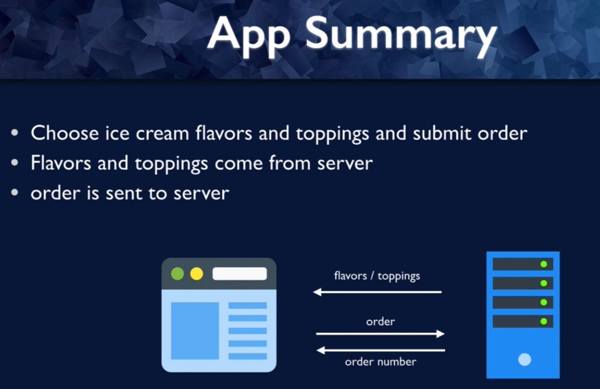

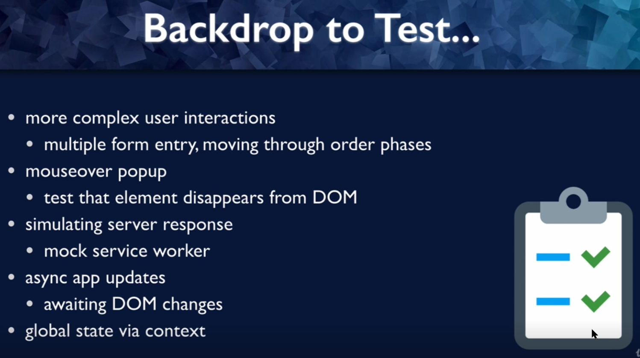

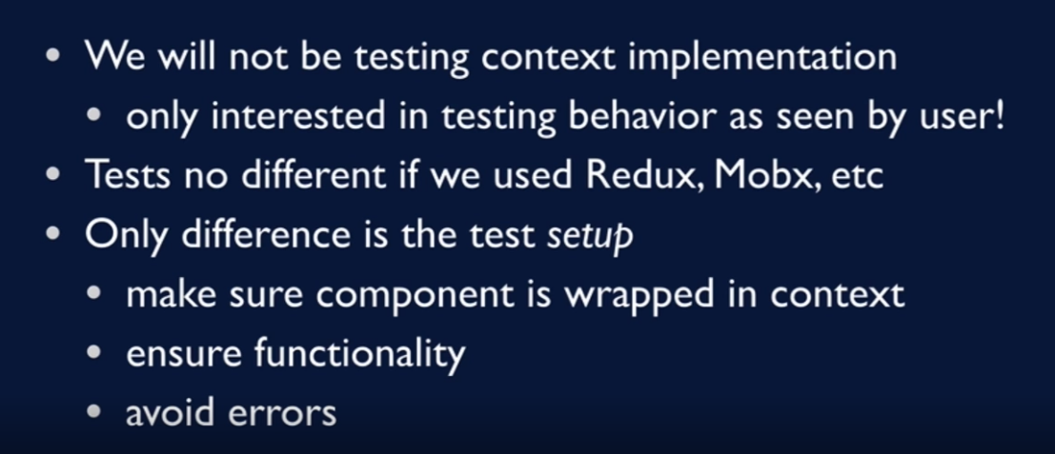

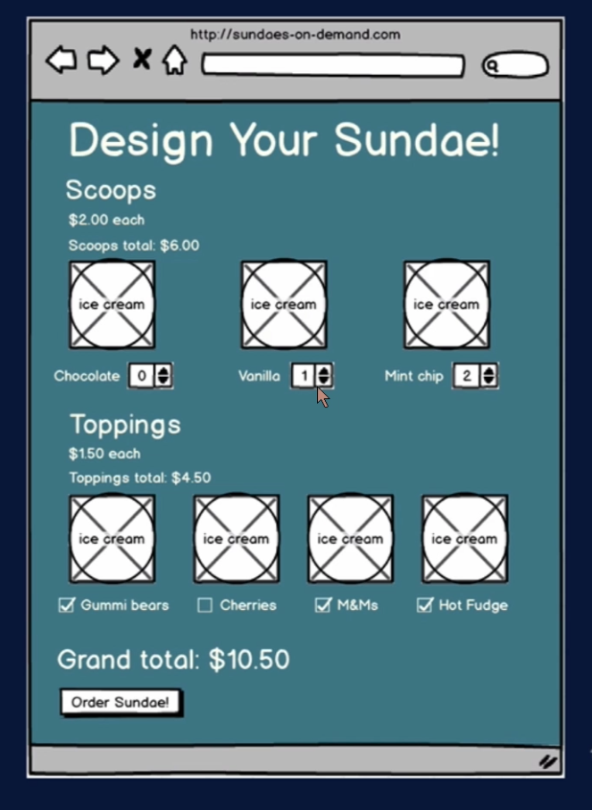

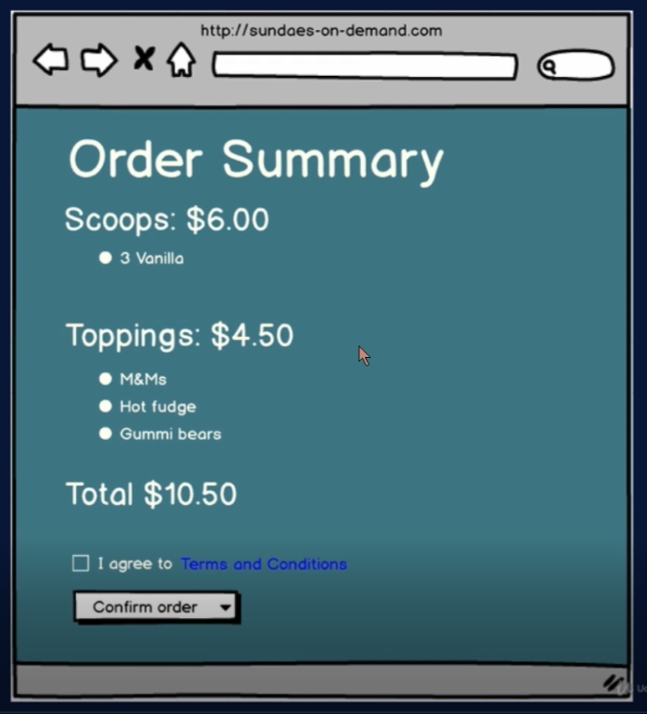

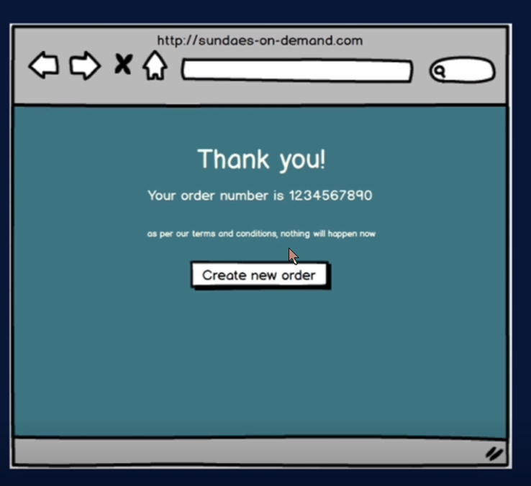

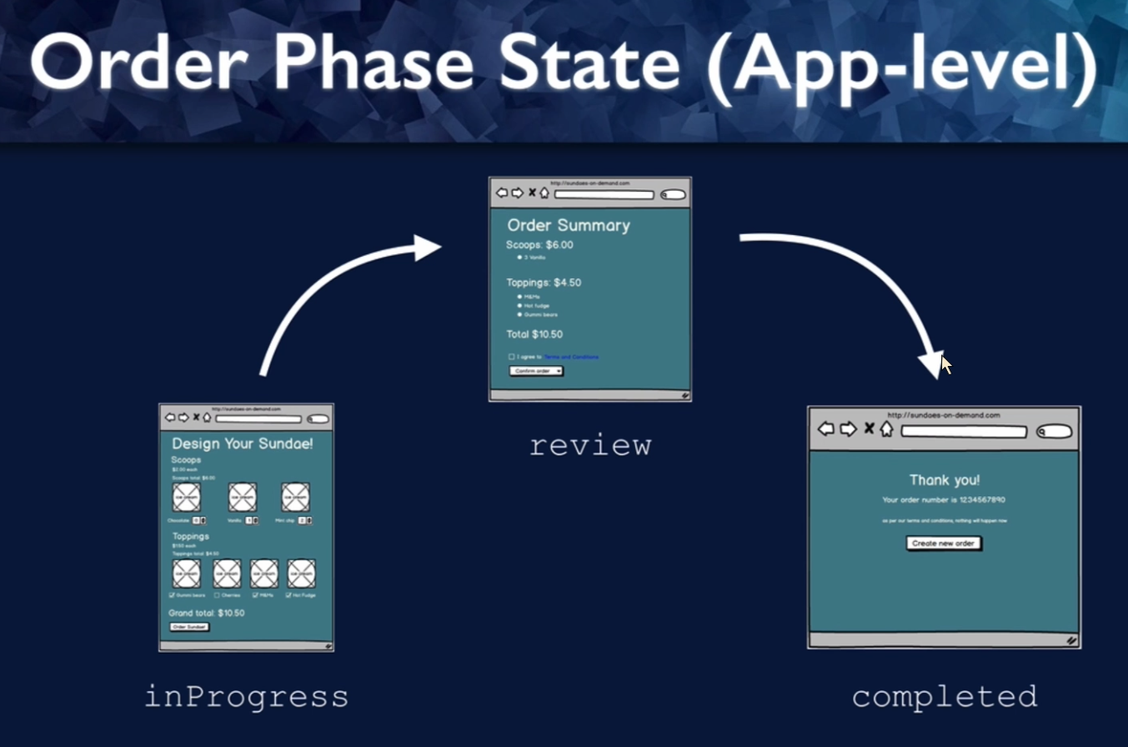

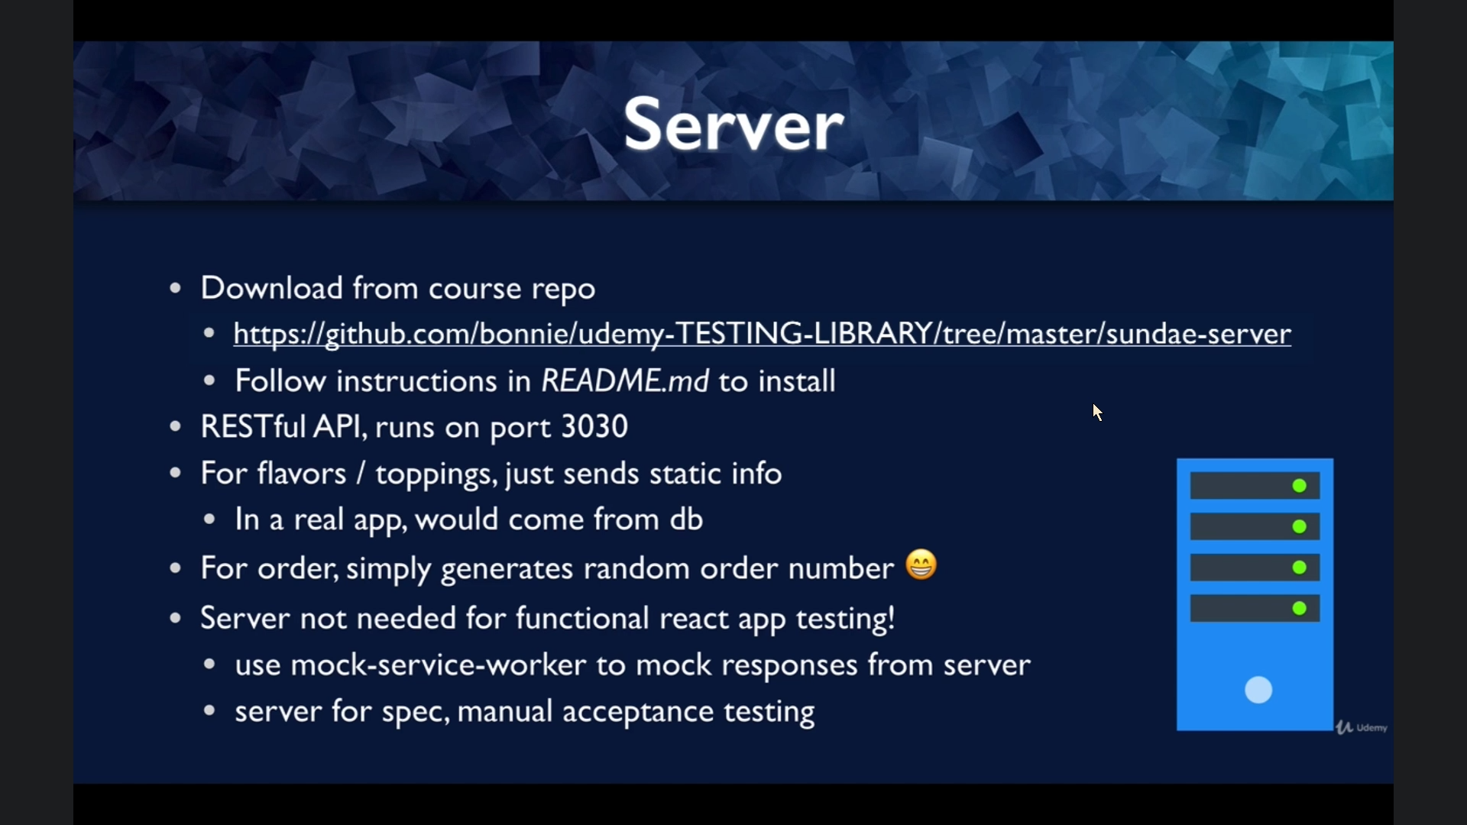

Note: Server have no roles in the test – just to ref the specs. **Mock-service-worker** will pay the deal

SETUP ESLINT AND PRETTIER FOR SUNDEAS

SETUP REACT-BOOTSTRAP

1. Npm install react-bootstrap bootstrap
2. Apply local style for react-bootstrap (browser globals)
   * <https://react-bootstrap.netlify.app/getting-started/introduction/#browser-globals>
3. Add css import to index.js
   * <https://react-bootstrap.netlify.app/getting-started/introduction/#css>

CODE ORGANIZATION

* Pages
  + Components.jsx
  + Test
    - Components.test.jsx

TESTING LIBRARY USE-EVENT

* The way component render will affect the way you find it in your test
  + Component unmount vs Component hidden (style: {visibility:hidden})
* User-event > click-event
  + <https://github.com/testing-library/user-event>

SCREEN **QUERY METHODS**

1. **Reference for screen query:**

* **Query API formal definition: https://testing-library.com/docs/queries/about/**
* **Quick specs sheet for query:** [**https://testing-library.com/docs/react-testing-library/cheatsheet/**](https://testing-library.com/docs/react-testing-library/cheatsheet/)
* **Which queries should i use:** <https://testing-library.com/docs/queries/about/#priority>

**SECTION 5: Simulating Server Response With Mock Service Worker**

**INTRODUCTION TO THE MSW AND HANLDERS**

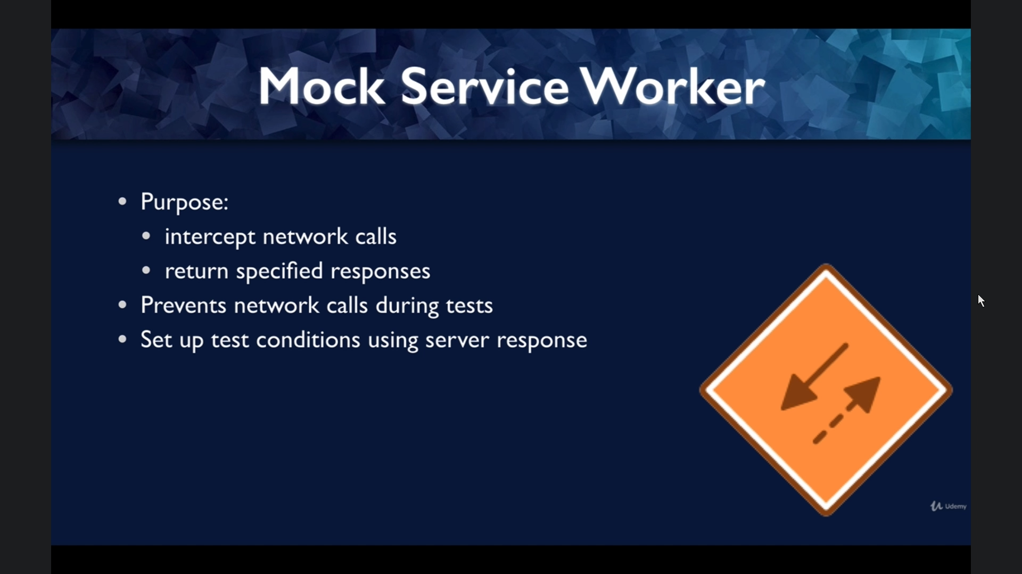

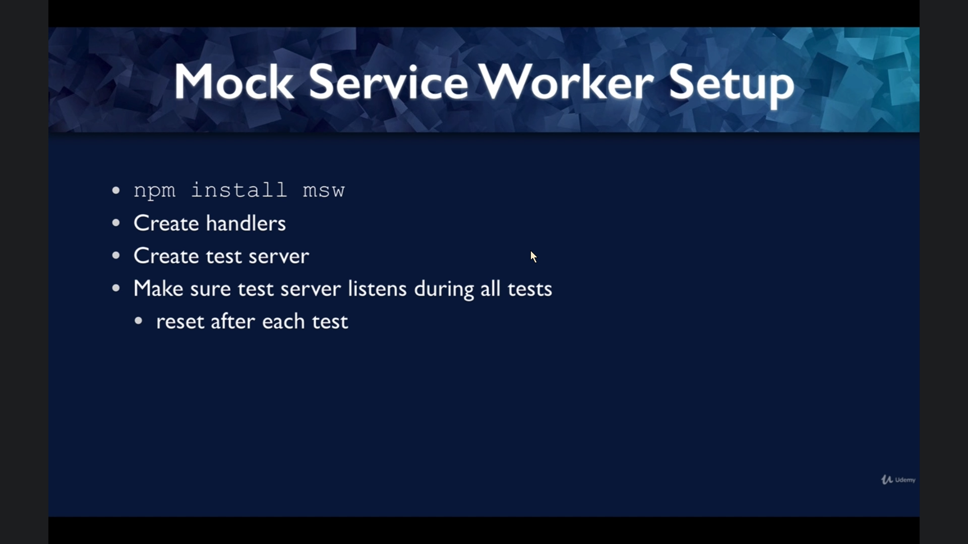

* **To define handlers**
  + **Create /src/mocks/handlers.js**
  + **Details like this: https://mswjs.io/docs/getting-started/mocks/rest-api**
  + **Server ref:** [**https://github.com/bonnie/udemy-TESTING-LIBRARY/tree/main/sundae-server**](https://github.com/bonnie/udemy-TESTING-LIBRARY/tree/main/sundae-server)

